The AWS Platform:

What do you need to know to pass the certified Solution architect Associate Exam:

Messaging

Desktop & App streaming

Security & Identity Management tools

Storage

Databases

Networking & Content Delivery

Compute

AWS Global Infrastructure. ------ Regions, availability zones and edge location (Caching to local server).

1. **Network and Content Delivery:**

**VPC (Virtual private cloud):** It is like virtual data center, where we are going to deploy your asset.

VPC are isolated from each other.

Exam perspective VPC is a very important topic.

**Route53:** Amazon DNS server. Register domain name through Route53.

1st is Route66.

**Cloud front:**  For caching data like video image and document etc.

**Direct Connect:**

1. **COMPUTE:**

**EC2:**

All EC2 are virtual machine in AWS.

**EC2 Container service:** Not exam related topic.

**Elastic Beanstalk:** Come up in Developer exam. Not in Solutions architect exam.

**Lambda:**  May come in Exam.

Very important topic in AWS.

**Lightsail:**  Does not feature in exam.

1. **Storage:**

**S3: Simple storage service,** oldest service of AWS. Featured in both Developer and solution architect exam.

It is a virtual storage in AWS where we can store objects. Objects like word doc, picture, video, etc.

**Glacier:** It is used for data archival. Where we archive object from S3 off. It is extremely low cost service.

**EFS:** (Elastic file service) File based storage, where we can share the data. And we can install application in EFS and share with multiple virtual machines using this service.

**Storage Gateway:** Way of connecting S3 to on premises data center or to your head quarter.

It is a virtual machine which communicate with S3.

Comes up in Solutions Architect exam, Not in Developer exam.

1. **Databases:**

Fundamental of all three Associate exam.

RDS: Relational Database service. RDS like Mysql, postgres sql , Sequel server,

DynamoDB: Non-relational database. Really very scalable.

It is very much important for Developer associate exam.

RedShift: Data ware housing solution, storing Big Data. Running log query in production database may slow down data production environment. We can move production data to redshift and run log query (Like net profit and all).

Does not featured in any of associate exam.

Elasticache:

Caching service.

Comes up in both developer and solution architect exam.

1. **MIGRATION :**

Snowball: Moving huge data into cloud.

Sysops and Solution

**DMS:** Database Migration services. On premises database to AWS.

Does not depends on the on premises database, we can migrate from any database to any.

We can migrate production database, there is no down time using replication.

Sever Migration Services (SMS): This target migration of virtual machine on premise. – Don’t come up in exam.

1. Analytics:

Athena: Allow you to run sequel query on S3. Not yet featured in any exam.

EMR: (Elastic map reducer) Come up in Solution architect, not in Developer associate.

Used for **big data** processing. Like log analysis.

Cloud search: For creating search engine in AWS. Fully managed by AWS. Do not come up in any of associate exam.

Elastic search: This is also for creating search engine in AWS. Do not come up in any of associate exam.

Kinesis: It is used to analyze and train real time data in massive scale. It can capture store

Tera-bite of data per hour. Analyzing market, financial data, centimate analysis of product like social media. Come up in Solution architect exam.

Data pipeline: Move data from place to other. Does not come up in any of associate exam.

Quick sight: Does not come up in any of associate exam. Business analytics tool.

1. Security and Identity:

IAM: Come up in all AWS exam.

Inspector: Inspect security.

Does not come up in any of Associate exam.

Certificate Manage:

Directory Service:

Come up in Solution architect exam. Need have good theoretical understanding.

WAF: Web application firewall. It gives application level protection.

Don’t come up in exam.

Arifacts: Does not come up in associate level exam.

1. Management tools:

Come up in all associate exam.

Cloud watch: Come up in Sys opps exam.

It is used monitor environment in AWS. We can monitor EC2, Disk utilization. RAM utilization , CPU utilization etc.

**Cloud formation: Infrastructure into code.**

**We need to know inside out. Associate level exam we need to have high level understanding.**

**Cloud trail : Auditing AWS resources and changes in aws.**

Opsworks: Used for auto deployment and configuration management

Config: Way of auditing aws environment, Using config we can set security alerts. Does not come up in any of associate exam.

Service Catalog: Not an exam topic.

Trust advisor: Automated way of scanning your environment and give tips to optimize.

How to Cost of optimizations, how to optimize performance, any security fixes you should make, How to make fault tolerant environment. Come up basic in Solution architect exam.

1. **Application Services:**

Step Function:

SWF: Simple work force service. Definitely comes up in all associate exam.

API Gateway: Gateway for application to access backend data.

Does not come up in any of the Exam.

App stream: Way of streaming your desktop application to users. Does not come up in any of associate exam.

Elastic transcoder: It transcode video to all different format. Does not come up in any of the Exam.

1. Messaging: Does come up in all associate level exam.

SNS: Simple notification services.

**\*SQS: It really comes up in Solution architect and developer associate exam.**

SQS is way of decoupling your applications, basically it’s a queue system.

SES: It is an email service. Sending and receiving emails,

1. Developer tool: Not yet featured in Developer associate exam.

Code Commit, Code Build, Code Deploy, Code Pipeline.

* [What is an AWS region?](javascript:void(0);)-- Geographical area having two or more availability zone.
* [Which statement best describes Availability Zones?](javascript:void(0);)--- Data centre.
* [An AWS VPC is a component of which AWS service?](javascript:void(0);)---- Network services.
* [What is a VPC?](javascript:void(0);)--- Virtual private cloud.
* [Which AWS service allows you to run code without having to worry about provisioning any underlying resources (such as virtual machines, databases, etc.)](javascript:void(0);) ---- Lambda.
* [Amazon's highly scaleable DNS service is known as ________.](javascript:void(0);) Route53
* [What is the difference between Elastic Beanstalk & CloudFormation?](javascript:void(0);)

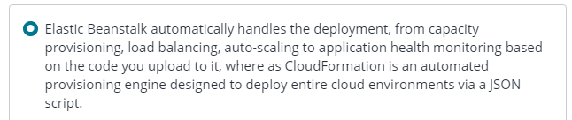

* [Which AWS service is used a CDN to distribute content around the world?](javascript:void(0);)---Cloudfront.
* [Which of the following AWS solutions offers durable, available storage for flat files?](javascript:void(0);)

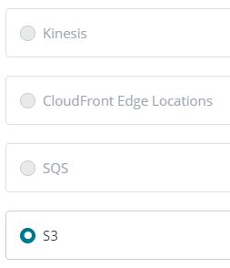

* [Which of the following AWS services would be the best choice for long term data archival?](javascript:void(0);)

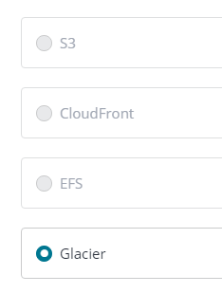

* [Which AWS service offers the following database engines: SQL, MySQL, MariaDB, PostgreSQL, Aurora, and Oracle?](javascript:void(0);)

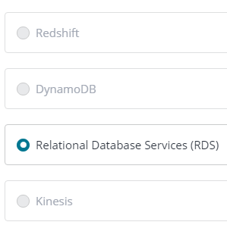

* [Which of the following AWS services is used primarily for data warehousing?](javascript:void(0);)

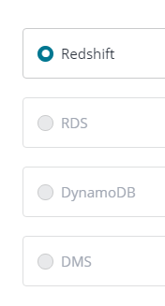

* [Which AWS service is used for collating large amounts of data streamed from multiple sources?](javascript:void(0);)

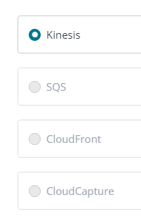

* [You need to add users to your AWS account and set password rotation policies for these new users. Which AWS service would best fit your requirements?](javascript:void(0);).

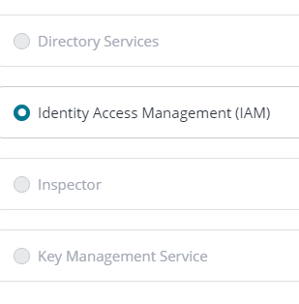

* [You need to supply auditors with logs detailing the individual users that provision specific resources on your AWS platform. Which service would best meet this need?](javascript:void(0);)

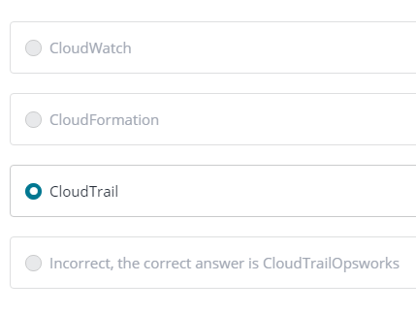

* [You need a configuration management service that enables your system administrators to configure and operate your web applications using Chef. Which AWS service would best suit your needs?](javascript:void(0);)

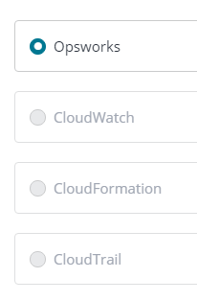

* [Your digital media agency needs to convert their media files in to different formats to suit](javascript:void(0);)

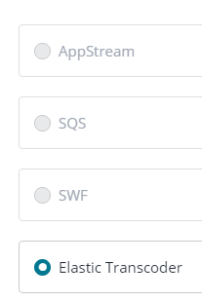

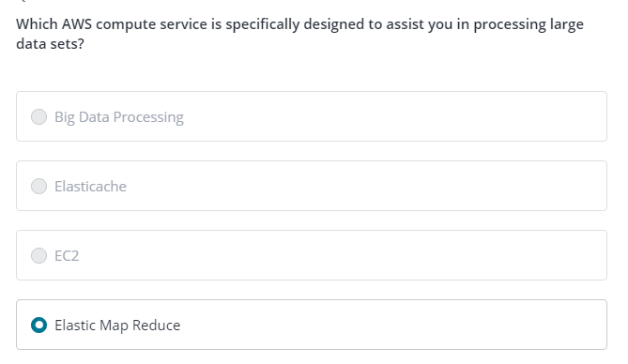

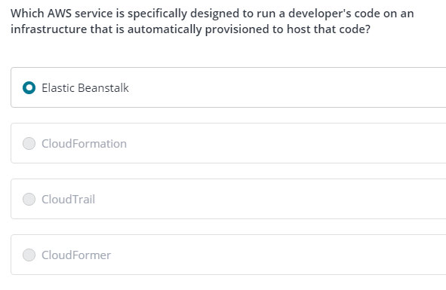

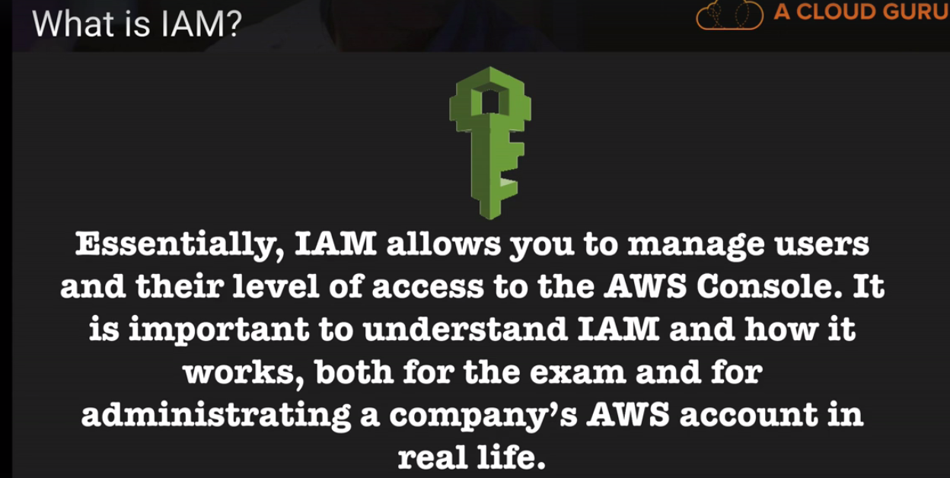

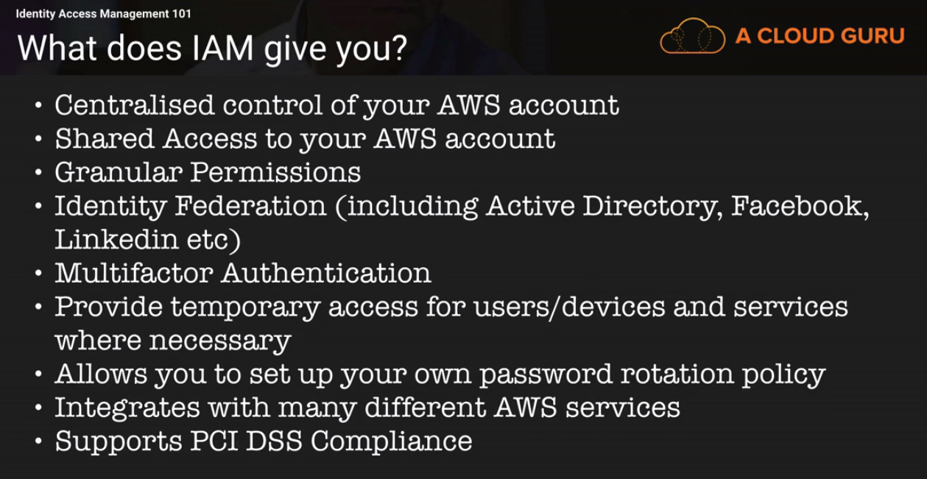

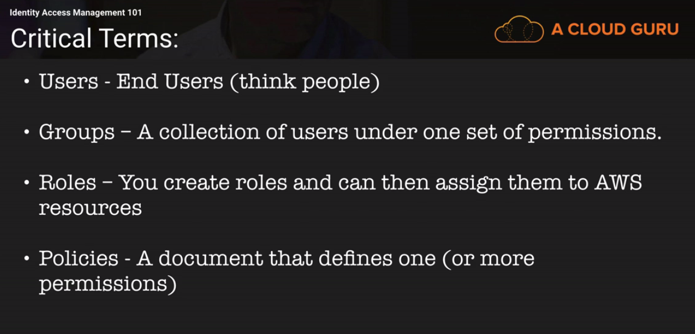

IMPORTANT NOTE:

1. IAM service has no specific region, it is global and available all over the AWS regions.
2. Access Key ID and Secret access key can be used to interact with AWS programmatically or from CLI. Those two cannot be used in console to access AWS.
3. Similarly, User id and password can be used in console to access AWS and cannot be used programmatically or in CLI.
4. Download .csv file containing those details.
5. Once we loss User id, password, access key and secret access key, all cannot be regenerated.

Only access key and secret access key can be regenerated. For rest we have recreate the id.

Attach permission/policies is for users as well as for groups.

Billing Alert come up in exam.

IAM summary:

